Implementation Assignment #3: Coordination
1. Based on your solution to programming assignment 2 that you worked on earlier, update the solution by adding a file on the server. Simulate having multiple clients accessing the file by adding or reading from the file. Run your code and show the results.
2. Discuss the approach that your solution took for the processes to communicate with the server and access the file?
3. Simulate increasing the number of processes accessing the file. What issues would you run into?
4. Based on the different coordination algorithms discussed in class, which one do you think will be a good solution for this problem? Explain your reasoning and how it applies to your solution.
5. Reflection on testing, observations, challenges, etc.
6. Submit the new updated code, fully documented with comments and resources used. You also need to submit the PDF showing all the testing you did on your code to support your answer, along with references.

Introduction (#1-2)
The environment that I used was Java 15+ with the package manager being Apache Maven. Using Docker, I created a compose.yml file that detailed the dependency order of the project. Alongside this I created Dockerfile.client and Dockerfile.server to have a custom startup with the client and server images respectively. With this after using docker compose up --build server command and the docker compose up --build --scale client=10 client, I was able to deploy this simple server and client server. The Client program will randomly modify or read from a file on the server. The clients will be taking this to the extreme where the poll to read and modify the files on the server. The clients will communicate through basic networking protocols.

Problems (#3-4)
We will additionally scale from 1, 10 to 100. The issues that came with increasing number of users was that files would be corrupted during the writing when reading. To mitigate this, I created a RetreantRWLock for the file on the server. The coordination-based algorithms that we would require to prevent these types of corruptions would be distributed locking and consensus algorithms such as ZooKeeper.
The server successfully built in Java and hard-coded exposed port 8080 for the clients to connect.
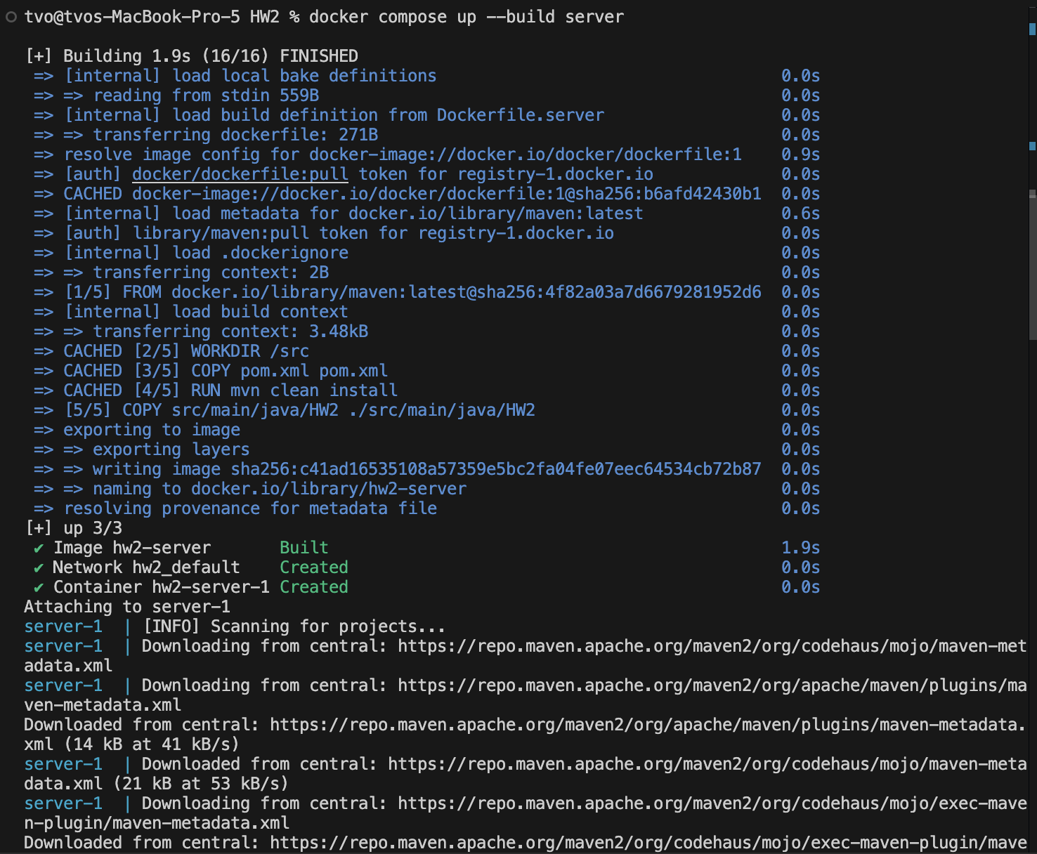
The client successfully built in Java to connect to the exposed port 8080.
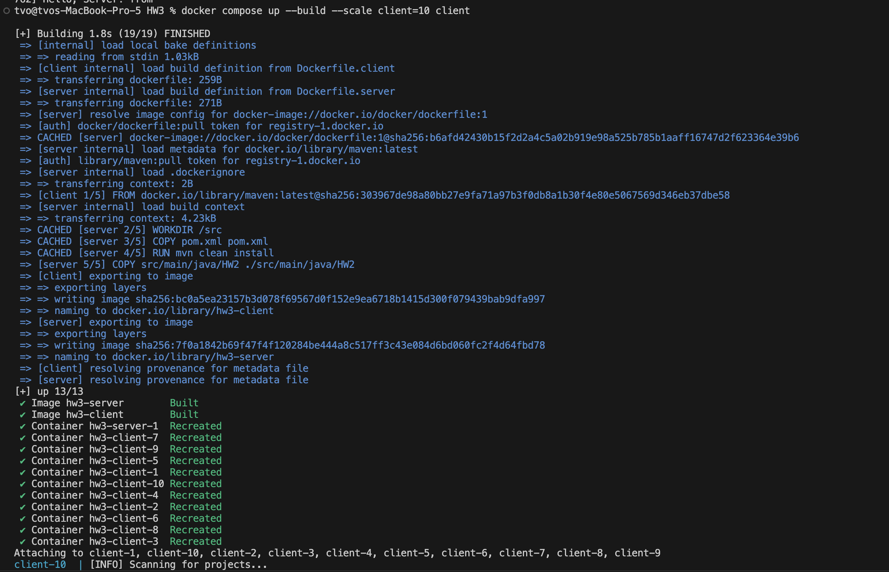
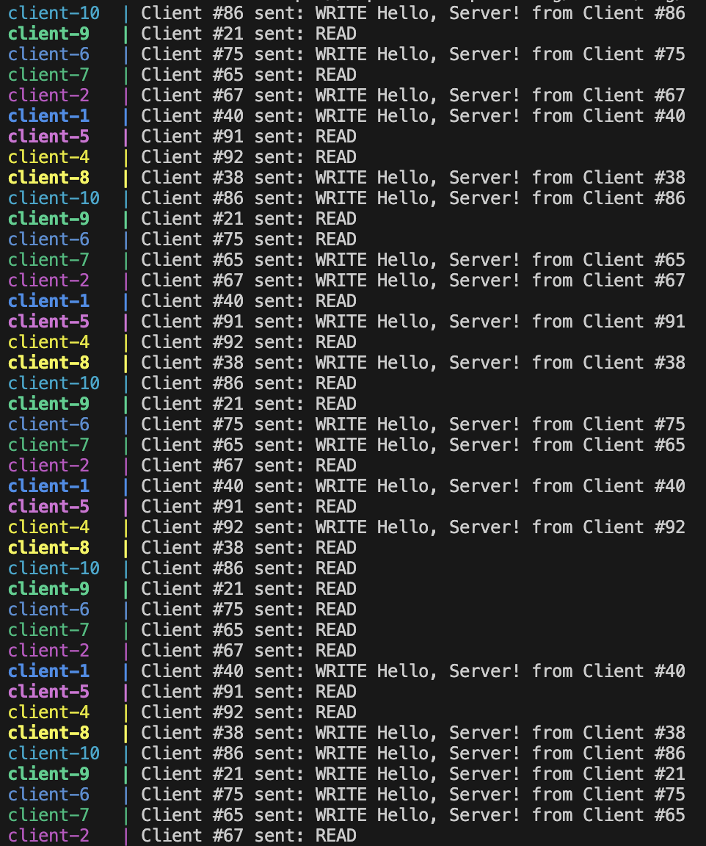

Reflection of Testing, Observations and Challenges
Testing was done before the deployment of the Server and Client. I used Apache Maven to test the Client and Server Application by mocking the expected output with the modified input or function call using the Java Library Mocktio. Using mvn clean test, you can run the tests created for the Client and server. Mocking the client needed to be updated since there should be a flag to notate sleeping messages or not from the previous assignment.
From my observations, the docker containers seems to be installing the same packages to the client images. This is interesting since I each image should be the same, but why is it that they are having duplicated installs without copying from another image to another.
One of the biggest challenges of this project was learning the coordination of the docker server container. When running multiple clients it would corrupt the file, but it was fast, but when implementing the lock, the read and writes were slower.
Testing
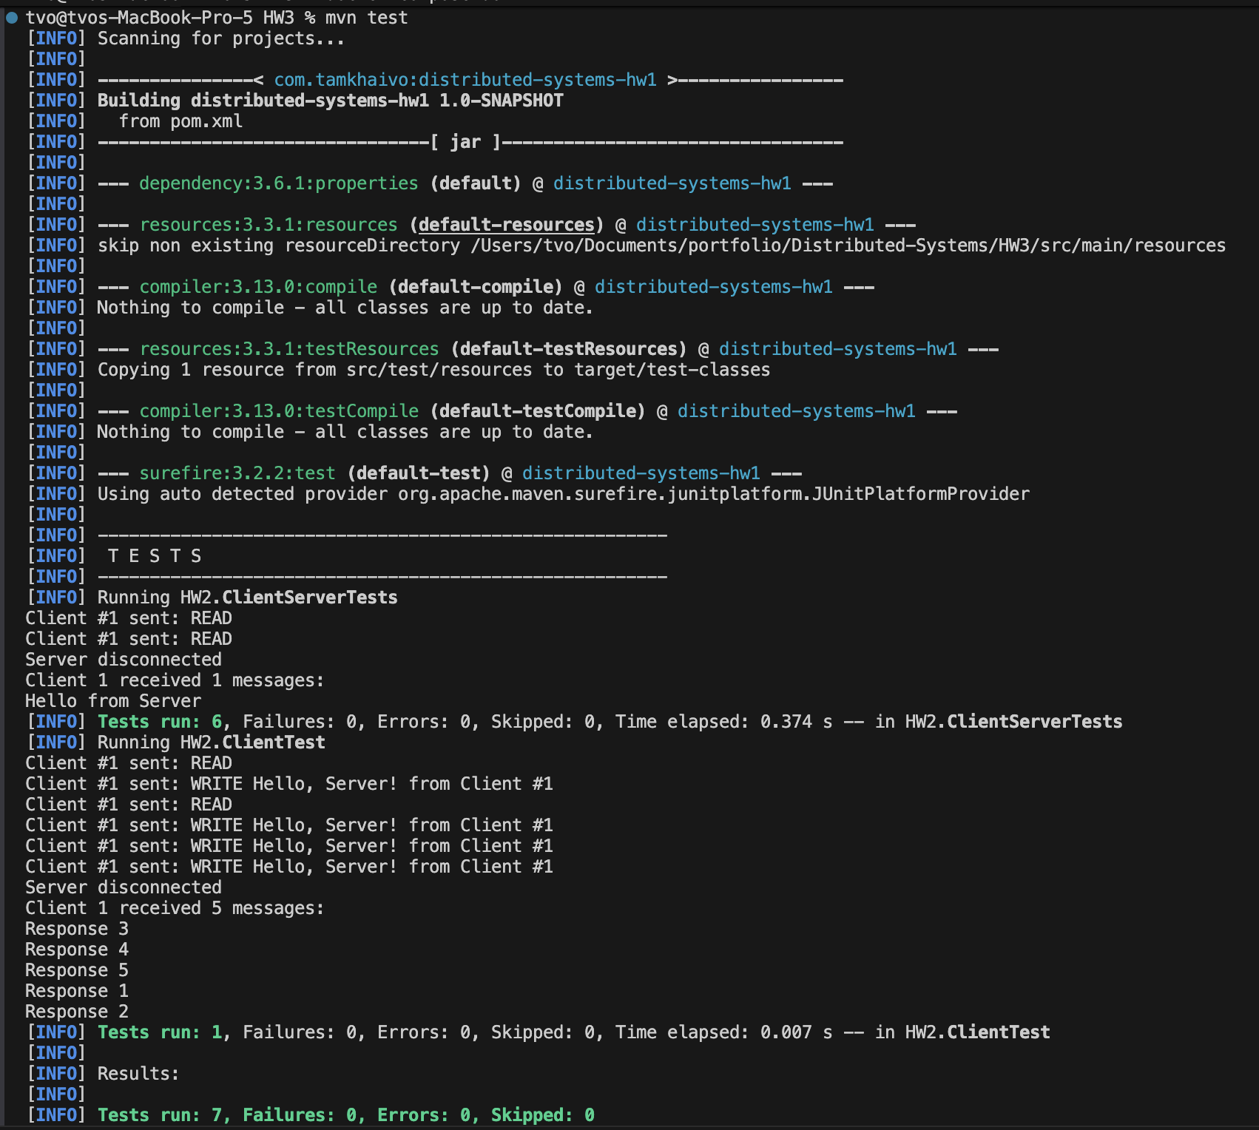

References
- https://site.mockito.org
- https://www.w3schools.com/java/java_threads.asp
- https://docs.docker.com/compose/
- https://www.geeksforgeeks.org/java/socket-programming-in-java/
- https://aws.amazon.com/builders-library/leader-election-in-distributed-systems/
- https://learn.microsoft.com/en-us/azure/architecture/guide/design-principles/minimize-coordination
- https://cloud.google.com/blog/topics/developers-practitioners/implementing-leader-election-google-cloud-storage
- https://learn.microsoft.com/en-us/azure/architecture/patterns/leader-election
- https://static.googleusercontent.com/media/research.google.com/en//archive/chubby-osdi06.pdf
- https://www.hashicorp.com/en/blog/making-gossip-more-robust-with-lifeguard

